**Kinematic Measurement Systems Lab 2**

**1 Main Task**

Realize the computation of the position of the tachymeter and the determination of two new object points (N5, N6) by the use of the polar elements.

**2 Specific Steps**

**2.1 Read out of the measurement data**

The first step is to get the measurement data from the Tachymeter using the program of Lab1. To do this a sub-program “lab2.vi” is built, which reads the output data from Lab1 and transmits to further steps. As is shown in Fig.1, the values are divided by comma to get “Horizontal angle”, “Vertical angle” and “Slope distance”. Afterwards these string values are transformed to numbers.

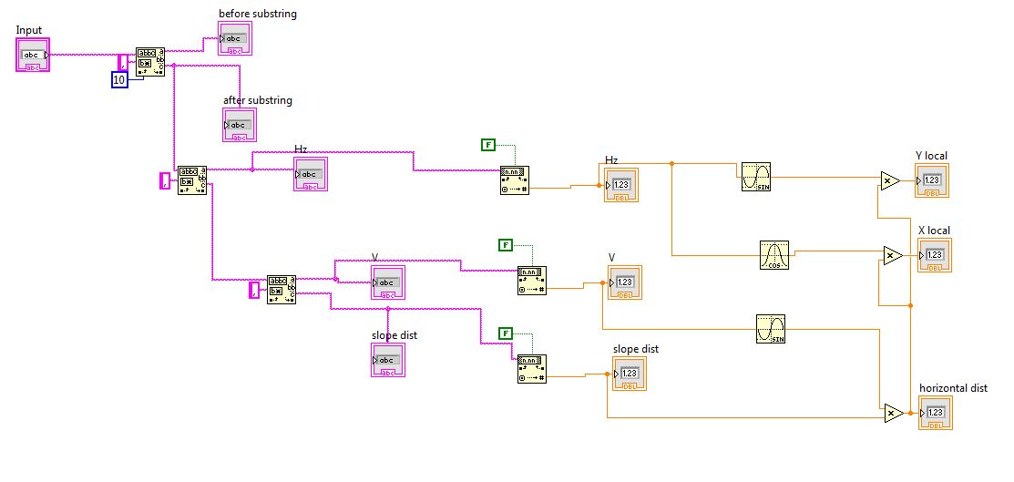

Fig.1 “lab2.vi”

**2.2 Reduction of slope distances**

What is needed in further steps are the local coordinates of measured points, before which the horizontal distances should be obtained. Therefore, another slope-to-horizontal transformation should be added to the data from 2.1. The right part of Fig.1 shows the transformation, and the formula is shown as follows:

$$s_{i}=d_{s}∙sin⁡(V)$$

Where $s_{i}$ is the horizontal distance, $d_{s}$ is the slope distance and V is the vertical angle.

**2.3 Computation of local coordinates**

After getting the horizontal distances, the local coordinates can be calculated with the following formulas:

$$y_{i}=s_{i}∙\sin{r_{i}}$$

$$x_{i}=s_{i}∙\cos{r_{i}}$$

Where x and y are the local coordinates, s is the horizontal distance and r is the horizontal angle.

2.1, 2.2 and 2.3 are integrated in lab2.vi, which is connected to the output of Lab1, and outputs the local coordinates of measured points.

**2.4 Transformation to global reference system using Helmert Transformation**

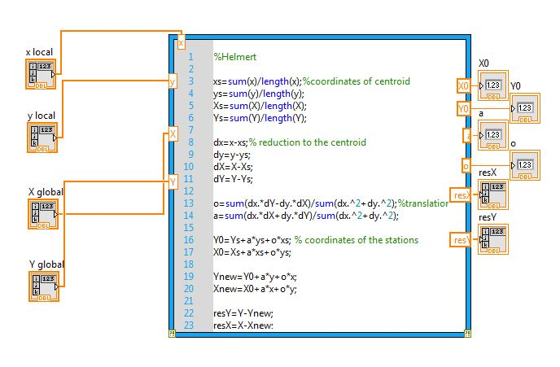

Fig.2 “Helmert-formula.vi”

Fig. 2 shows the sub-program “Helmert-formula.vi” of transforming coordinate systems. To transform the local coordinates into global reference system, the centroid coordinates of both coordinate systems are first calculated:

$$y_{s}=\frac{\left[y_{i}\right]}{n}, x_{s}=\frac{\left[x_{i}\right]}{n}$$

$$Y_{s}=\frac{\left[Y_{i}\right]}{n}, X_{s}=\frac{\left[X_{i}\right]}{n}$$

Then the points are shifted to the centroid:

$\overline{y_{i}}=y_{i}-\frac{\left[y_{i}\right]}{n}, \overline{x_{i}}=x_{i}-\frac{\left[x_{i}\right]}{n}$

$$\overline{Y_{i}}=Y_{i}-\frac{\left[Y_{i}\right]}{n}, \overline{X_{i}}=X_{i}-\frac{\left[X_{i}\right]}{n}$$

And the Helmert formula is used to calculate the transformation parameters *o* and *a*:

$$o=\frac{\left[\overline{x_{i}}∙\overline{Y_{i}}-\overline{y_{i}}∙\overline{X_{i}}\right]}{\left[{\overline{x_{i}}}^{2}+{\overline{y_{i}}}^{2}\right]}$$

$$a=\frac{\left[\overline{x_{i}}∙\overline{X_{i}}-\overline{y_{i}}∙\overline{Y_{i}}\right]}{\left[{\overline{x_{i}}}^{2}+{\overline{y_{i}}}^{2}\right]}$$

Finally, the coordinates of the station are calculated using the following formula:

$$Y_{0}=Y_{S}-a∙y_{s}-o∙x_{s}$$

$$X_{0}=X_{S}-a∙x_{s}+o∙y_{s}$$

$$m=\sqrt{a^{2}+o^{2}}$$

where m is the scale factor.

To check the residuals the following formulas are used:

$$v_{X_{i}}=-X_{0}-a∙x_{i}+o∙y_{i}+X_{i}$$

$$v_{Y_{i}}=-Y_{0}-a∙y_{i}-o∙x_{i}+Y_{i}$$

And

$$\left[v_{Y_{i}}\right]=0, \left[v_{X_{i}}\right]=0$$

To check the accuracy, a standard deviation is used:

$$s_{x}=s_{y}=\sqrt{\frac{\left[v_{X_{i}}v_{X_{i}}\right]+\left[v_{Y_{i}}v_{Y_{i}}\right]}{2n-4}}$$

And

$$\left[v_{X_{i}}v_{X_{i}}\right]+\left[v_{Y_{i}}v_{Y_{i}}\right]=\left[{\overline{X_{i}}}^{2}+{\overline{Y_{i}}}^{2}\right]-\left[a^{2}+o^{2}\right]∙\left[{\overline{x_{i}}}^{2}+{\overline{y_{i}}}^{2}\right]$$

In this step 4 points are used as control points to calculate the transformation parameters. To control the input points of the Helmert transformation, a while loop is built before the program goes to the Helmert transformation, where it is allowed to change which points to be input as control points and control the process of Helmert transformation.

**2.5 Determination of the coordinates for two new object points N5 and N6**

After getting the transformation parameters, the coordinates of new objects can be calculated. To do that, it is needed to first build another “tachymeter control and data reading out” component to measure the new points, and then adding again the local coordinates calculation sub-program as has been shown in 2.3.

Then, the new points can be calculated first to local coordinate system:

$$y_{N}=s_{N}∙\sin{r_{N}}$$

$$x_{N}=s_{N}∙\cos{r_{N}}$$

And then to global system:

$$Y_{N}=Y_{0}+a∙y_{N}+o∙x_{N}$$

$$X_{N}=X_{0}+a∙x_{N}-o∙y_{N}$$

Table.1 shows the calculated global coordinates of point N5 and N6.

**Table 1: Coordinates of the new point N5 and N6**

|  |  |  |
| --- | --- | --- |
|  | Y | X |
| N5 | 17409.1800 | 6469.2394 |
| N6 | 17409.1741 | 6453.6253 |

**2.6 Data storage into file**

Finally, the global coordinates of new points are output into files by connecting the previous results to a new added “Write text to file” button.

The whole main program is shown as Fig.3.

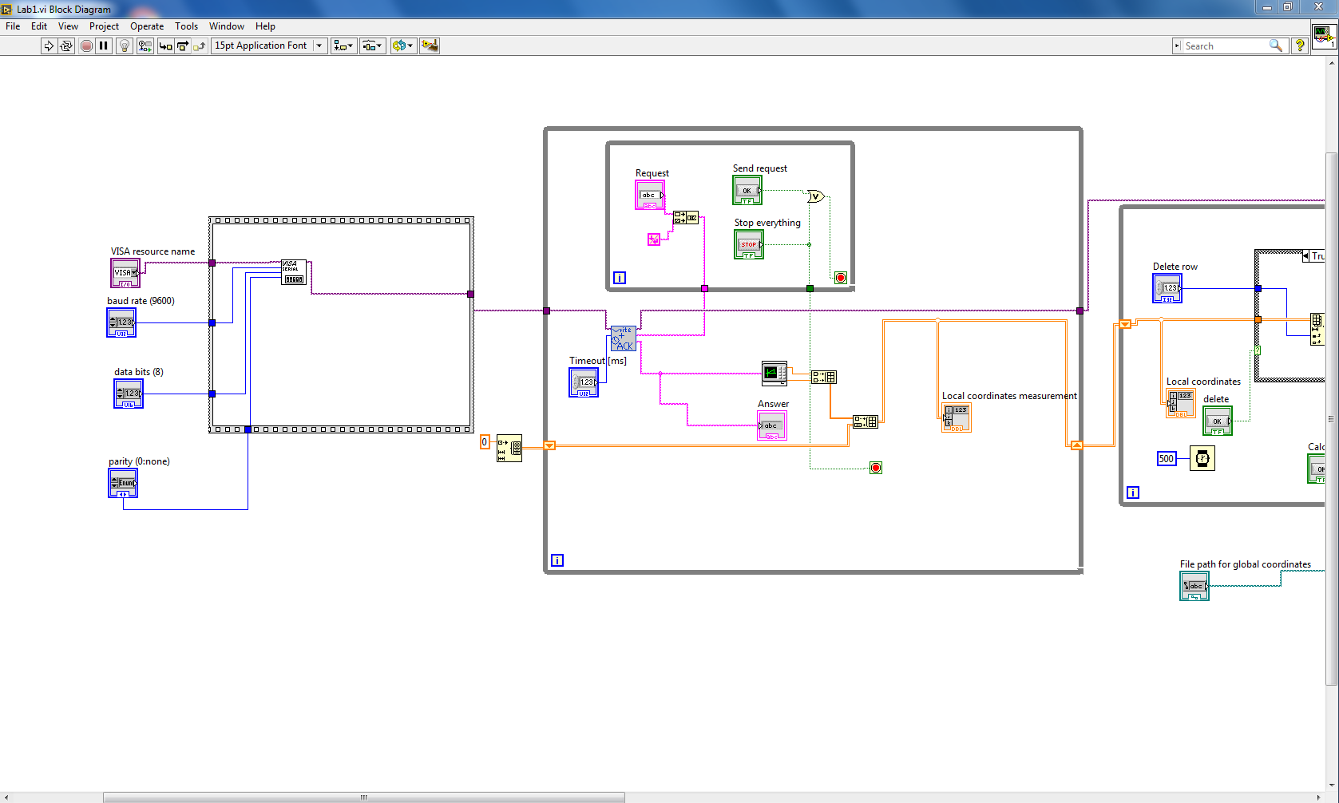

Fig.3 Main Program (part 1)

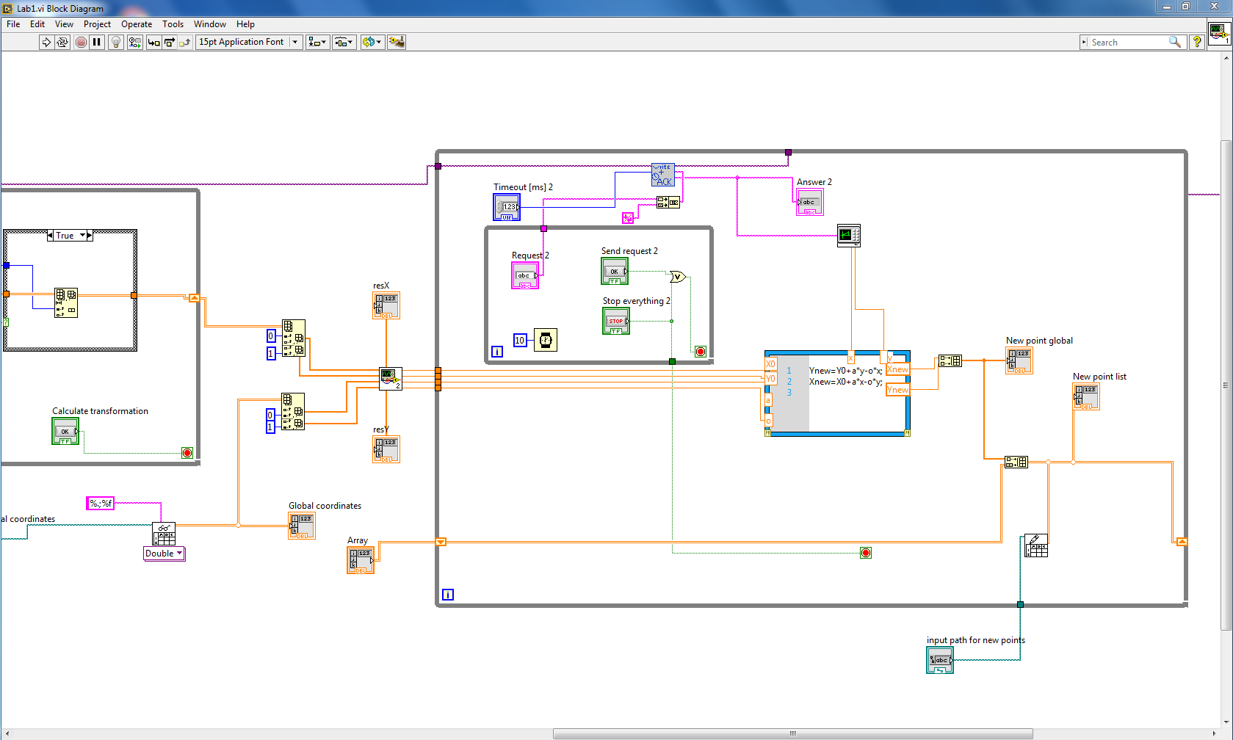

Fig.3 Main Program (part 2)

**3 Testing Results**

Fig.4 shows the testing program “Test.vi”, where the transformation is tested with testing data. Fig.5 shows the test results, from where it can be seen that the calculated coordinates of the station are the same as given values, and the residuals are successfully small, which proves the correctness of the program.

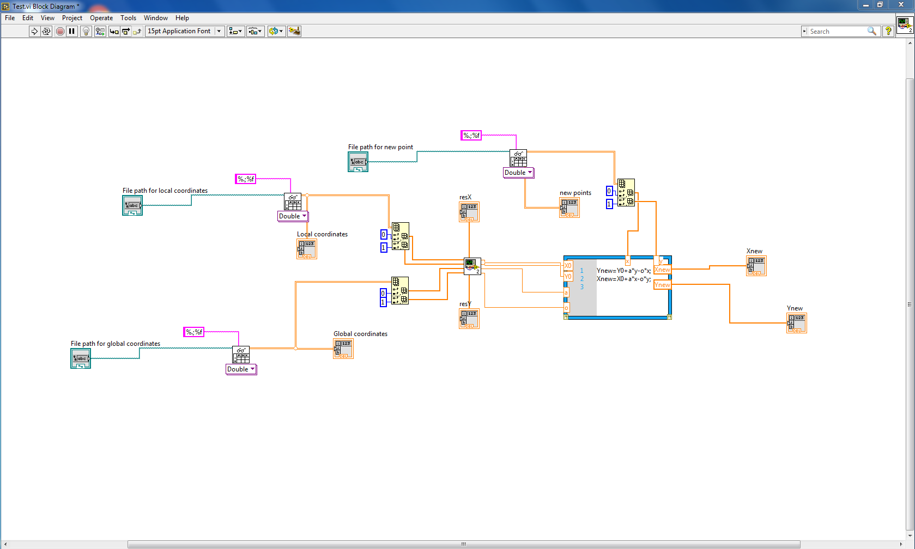

Fig.4 “Test.vi”

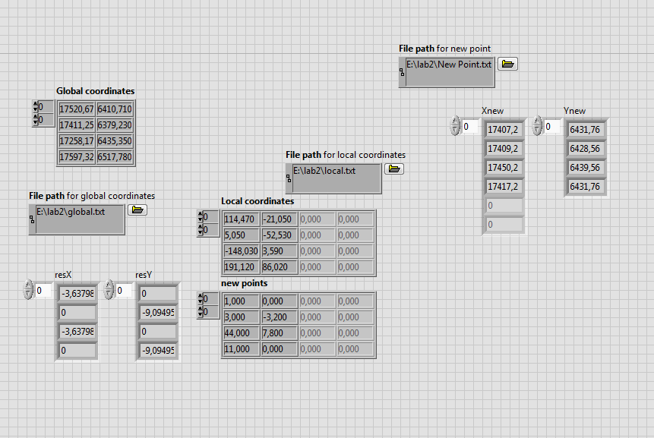

Fig.5 Test Results

**4 Float Chart**

Helmert Transformation

Output Transformation Parameters

Request

Send to tachymeter

measuring

Output Measurements

Reduction of Slope Distance

Calculate Local Coordinates

Stop?

**YES**

**NO**

Calculate Global Coordinates

Output New Points

***End***

***start***

Initializing

Request

Send to tachymeter

measuring

Output Measurements

Reduction of Slope Distance

Calculate Local Coordinates

Stop?

**NO**

**YES**

Delete Row?

**YES**

**NO**